**Api Url:**

**POST REQUEST:**

**http://127.0.0.1:5000/**

**Body:**

{

"batch": [

“image_base64”,

“image_base64”,

“image_base64”

]

}

**Success Response:**

**Status Code:** 200 OK

**Time:** 60ms- 130ms **(For 1 image)** --> 200ms- 300ms **(For 3 images and 2 blank images)**

**No image:**

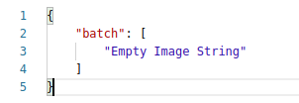

**1 image:**

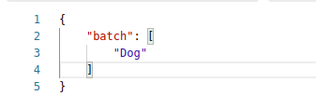

**N images:**

